Glendive Coach Receives Mixed Responses over ‘Culture of Mediocrity’ email
By KYLE HANSEN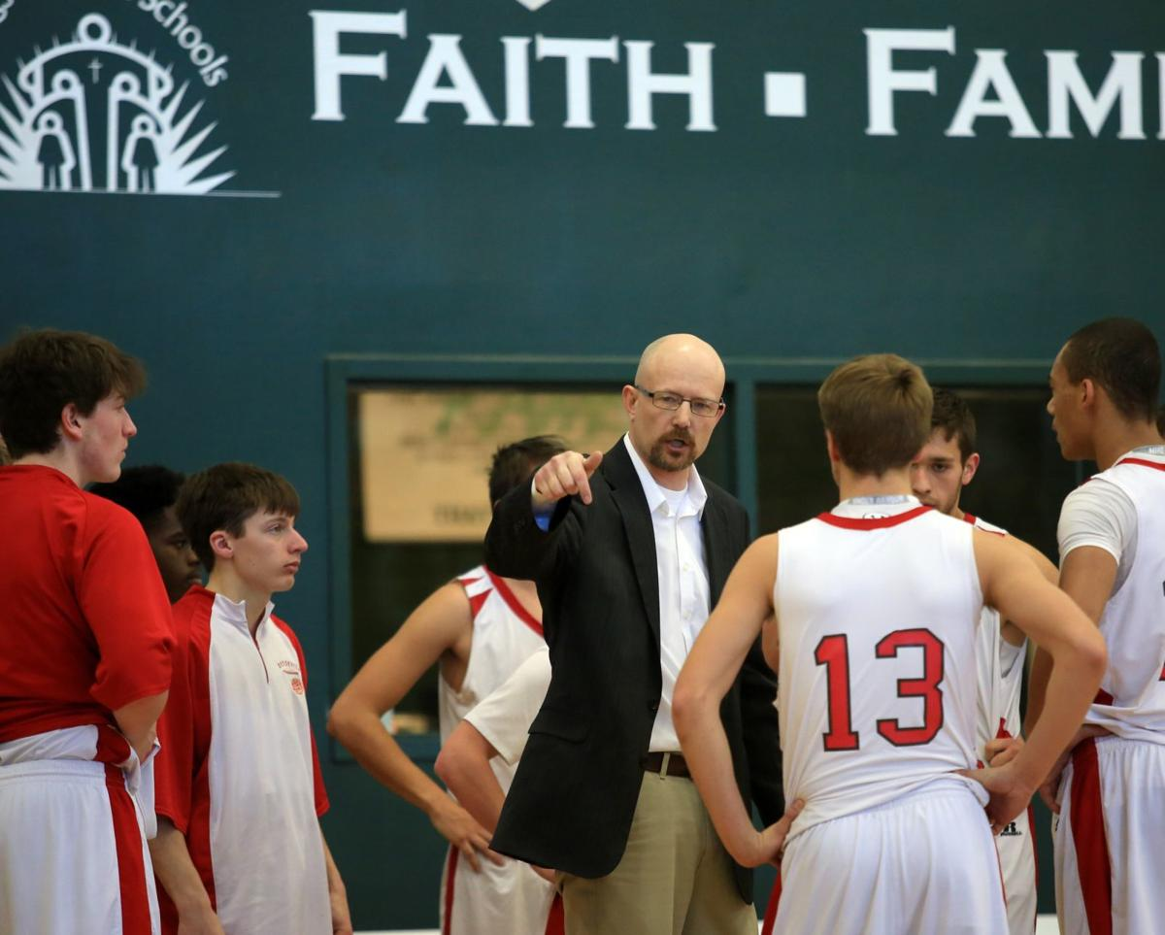
Glendive's boys basketball coach Wade Murphy talks to his team during a timeout during Glendive's 77-36 loss at Billings Central High School on Saturday, January 14. Murphy wrote an email saying Glendive had a "culture of mediocrity" due to the lack of success in the athletic programs. BRONTE WITTPENN, Gazette Staff

What's the difference?

That's the question Glendive's principal and boys basketball coach Wade Murphy has been fielding for quite some time.

Last week, the coach candidly answered.

After both Laurel and Billings Central soundly defeated Glendive on Jan. 13 and 14, Murphy was once again asked by a multitude of people why his team fails to compete on the same level as the Locomotives, Rams and others on a consistent basis. A question he said he's been asked for many years, he wrote in an email to the Glendive Ranger-Review explaining what he saw as the biggest difference.

"People ask me all the time what the difference is between our kids and the kids from those schools. The answer is simply one thing — a culture of expectations for individual improvement," Murphy wrote in his email to the Ranger-Review. "The students in those schools that participate in activities have a much higher expectation of commitment to improve than we have for our kids in our community."

The email was then run as a column, appearing in last Wednesday's Ranger-Review print edition. The story made its way online on Saturday and quickly began making the rounds on social media sites like Facebook and Twitter.

Murphy said he's been receiving a plethora of texts, calls and emails from people not only in Montana and his community, but from parents and coaches in other states as well.

As expected, some feedback has been negative, but the coach says he's heard plenty of positive responses.

"I've gotten emails from Indiana and Iowa. I've gotten phone calls from Oregon, Indiana and Wyoming, basically all positive," he explained over the phone on Tuesday. "(They were) saying that there was a lot of things in there that struck a chord with them and a lot of them said they were appreciative someone put it out there. A guy from Wyoming said, 'I felt like I was reading a conversation our coaching staffs have had for many years.' Another one from Iowa said, 'You said what many of us have been thinking for years.'

"The article itself was written in response to certain people in our community feeling like we are not competing with those schools. 'What's the problem? Why not?' To which I just replied, basically we don't have the competition here that forces our kids to get better. That really upset a lot of people in our community."

In the email, Murphy stated, "What we’ve created is a culture of mediocrity. We’ve rationalized our results with excuses."

The Glendive community is where the responses become more mixed.

"The feedback I've gotten has all been positive from outside of our community. There's a lot of people in our own community that are fairly upset that I put that out there," Murphy said. "That's fine, but once again, it was more about someone asking a question and me answering it."

Some of the negative responses, Murphy said, were, "'I'm just making excuses for losing'. 'I've had more talent than anybody and we haven't won with it'. I've heard, 'I'm too mean and kids don't want to play for me.'"

Murphy is in his 11th year as the principal at Glendive, and 10th year as the boys basketball coach. The Red Devils are 1-10 this year, their lone win coming over Class B Wolf Point (2-10). In the weekend before he wrote this, his team was defeated by Laurel 73-27 and by Billings Central 77-36. In his 10 years as head coach, the Red Devils haven't made the state tournament.

The football team hasn't made the playoffs in 19 years. The team had four different coaches during that time span.

He let his players know about what he wrote shortly after.

"It's probably a short compilation of everything I tell them everyday," he said. "I told them that. I told them there wasn't going to be anything in there that they haven't heard before. It's stuff I tell them constantly. They smiled and nodded their head. I'm sure some agree, disagree, or don't understand, but at the end of the day we're trying to help these kids."

Murphy wrote that kids don't take enough time in the summers and offseasons to put in the work necessary to compete at a high level. He said kids know they'll play varsity whether they practice in the offseason or not because not as many kids try out for the sports as they do at other schools. Students know they'll make the team, and are content with doing just that rather than spending their time in the offseason training knowing their spot on the team is in jeopardy.

In short, it's not as competitive to make the team.

"I don't think they're bad kids, it's just you can't want to compete but not want to pay the price for being competitive," Murphy said. "There's just some things here as a community we have to really reconcile ourselves with if we want to compete and that's what the whole thing was about.

"It's just one of those things where it comes down to what is it going to take to change, and maybe this will be it. I'll be honest with you, who knows, I might get run out of town over this deal but if it does, I've got friends left here who've got kids in school. Maybe it'll make a change for them and people will take a hard look at it. I stand by what I say and I hope that in the end this does more help than harm."

